PRODUCT REQUEST FORM
PRODUCT NAME: | Sterile Pre-Wetted with 70% IPA Wipers
DESCRIPTION OF REQUEST:  - New Product  - Modification  - Product Extension  - Country addition  - Label Change  - Intended Use  -…Etc… | Establishing a strategic distribution partnership to supply Sterile, Pre-Wetted 70% Isopropyl Alcohol (IPA) Wipes from a leading U.S. manufacturer to the compounding pharmacy market. This initiative is a critical execution of our company’s strategic pivot to become a premier one-stop service distributor for this sector.  Project Background  The U.S. compounding pharmacy market, valued at $15.6 billion, relies on a consumables segment worth $2.34 - $3.12 billion. and a projected CAGR of 7% (2025~2035). Core to pharmacy operations is strict adherence to USP <797> and <800>, where sterile 70% IPA wipes are a non-negotiable, high-frequency consumable for disinfecting ISO 5 cleanrooms and equipment.  However, sourcing this product from China presents significant regulatory and quality assurance hurdles, making it an inefficient path to market. Conversely, developing our own branded wipe would delay our entry and dilute resources from our core distribution strategy.  Therefore, the optimal strategy is to distribute an established, trusted U.S. brand. This approach:  - Aligns perfectly with our strategic direction to be a "one-stop total solution" distributor, not a manufacturer, for compounding pharmacy consumables.  - Provides immediate market access with a pre-validated, compliant product that pharmacists recognize and trust.  - Mitigates regulatory and supply chain risk by leveraging the partner’s existing certifications and domestic production.  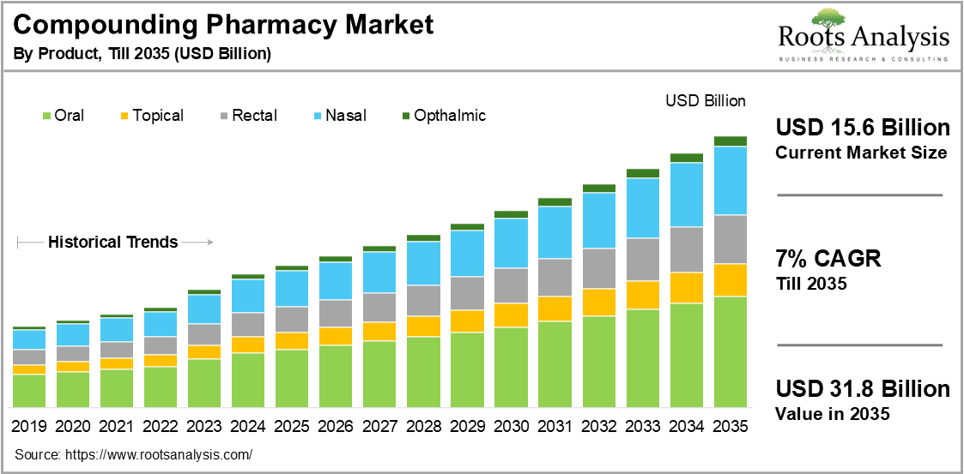
PURPOSE OF REQUEST: | ☐Complaint No. ☐Supplier ☒New market_______US_________  ☐Customer ___ ☐Internal _ ☐Other________________________  Add details:
ESTIMATED BENEFITS: | ☒ Financial Benefit: __Complete the product lines for the allergy clinics markets, Annual sales amount 500K ____ (Mandatory For NPD request)  Estimate the potential increase in cash flows, revenues, or any other financial benefits  ☐ Cost Saving:__________  Decrease in the cogs, transportation or operation expenses, or any other cost-saving opportunities  ☐ Improved Operational Efficiencies:_________  Decrease in the Lead time, delivery time, MOQ, Inventory, or any other efficiency improvement  ☐ Non-Financial Benefits:_________  Quality Improvement; Enhanced customer satisfaction, product competition, Brand reputation, etc.  ☐ Other Benefits:__________
PRODUCT DESCRIPTION:  - Functional performance requirements  - Appearance  - Any unique points of differentiation against similar competitor product lines  . ..Etc… | Product Definition & Scope 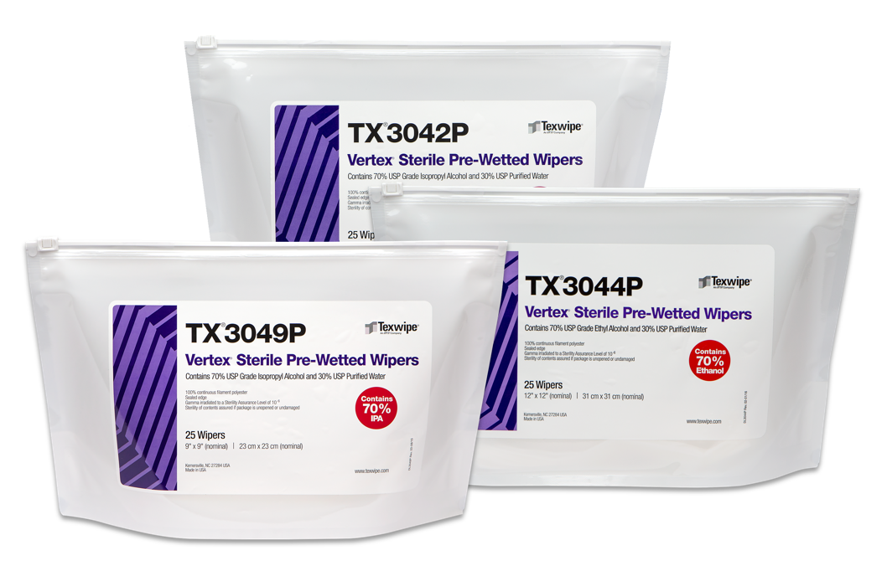  This NPI defines a business partnership model, not a manufacturing project.  - Product: Sterile, low-linting 70% IPA wipes from a selected, reputable U.S. manufacturer.  - Primary Use: Critical for disinfection protocols in sterile & hazardous drug compounding workflows.  - Our Value Proposition: We will act as a strategic distributor, offering competitive pricing, reliable logistics, and bundling with our expanding portfolio of compounding supplies. Our role is to provide service, convenience, and consolidated sourcing for our pharmacy clients.  3. Agent Brand Proposal  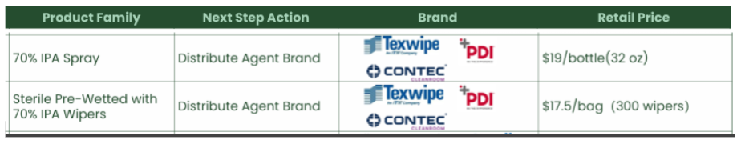
REQUEST TYPE | ☐LCR (Labelling Change Request)  Changes on the labels without changing the products  ☐SCR (Supplier Change Request)  Change applications initiated by Suppliers  ☐ECR (Engineering Change Request)  Existing products that SOLM is the legal manufacturer  Engineer changes that are not bringing new hazards/risks  ☐NPD (New Product Development)  Develop new innovative products that SOLM will be the legal manufacturer  Significant changes on existing products that may bring new hazards/risks or new intended use  Change products from outsourcing to SOLM to be the legal manufacturer  Development of VET/Component products  ☒SDP (SOLM Distributor Product)  New product introduction that SOLM will not be the legal manufacturer  No change on the product, no SOLM information on the labels  ☐SPP (SOLM Portfolio Product)  New product introduction that SOLM will not be the legal manufacturer  No change on the product, Add SOLM information on the labels  ☐Customized Product / Market  Purchased products that SOLM is not the legal manufacturer  Engineering change on products or new customized products requested by SOLM  New Market region requested by SOLM
TARGET MARKET: | ☒ US ☐ Canada ☐ EMEA ☐ UK ☐ Brazil ☐ Australia & New Zealand ☐ Other countries/regions, list:
TARGET USE: | ☒ Human Use  ☐ Animal Health | STERILE | ☒ YES  ☐ NO
VOLUME/SALES OPPORTUNITY: | Launch volume required: | Yr 1 estimate | Yr 2 estimate
CUSTOMER NOTIFICATION | Do we have any special quality agreement in place with customer which requires approval before implementing changes? ☐ YES ☒ NO  If Yes, please provide the customer's name and evidence.  Attach the customer confirmation GF-0083 at the end of the form.  Is notification to the customers needed after change project is closed? ☐ YES ☒ NO  Remark:  Example: change affect regulatory, performance, appearance, etc. Notification method.
LEGAL MANUFACTURER: | ☐ Sol-Millennium  ☒ Other: __________ | BRANDING | ☐ Sol-Millennium  ☐ Private Label
EXPECTED PRODUCT LAUNCH PERIOD: | ☒ < 1 year  ☐ 1-3 year  ☐ > 3 years | EXPECTED PRODUCT LIFE PERIOD: | 10 years
NAME AND DATE of REQUEST: | Alex Lu 2026/1/30

